Lineage Graph which shows how data is processed through the bronze, silver, and gold layers, and what tests are applied
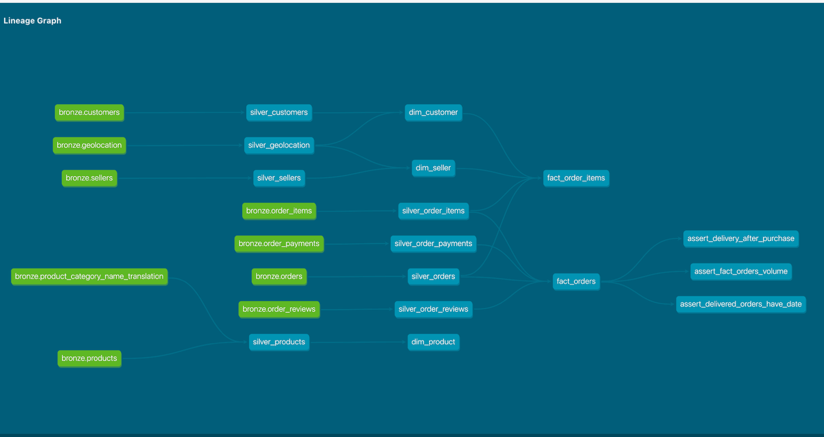
Dbt commands
Dbt run – executes compiled sql models against the target database to materialize tables or views
Dbt test- runs data quality and integrity tests defined on the models, sources, snapshots, and seeds
Dbt build – builds and tests all selected resources in dependency order
Dbt seed – loads CSV files from the project seeds directory directly onto your database
Dbt debug – test database connection settings and validates the local project setup
Dbt docs generate – parses your project metadata to build a complete documentation website containing model definitions and lineage graphs
Dbt docs serve – launches a local web server to host and view the generated dbt project documentation
Git
-do git push -u origin <branch_name> to push local branch to remote repo and it as the tracking upstream
- to switch to branch main - git switch main
-delete a branch – git branch -d feature/data-quality
-create and switch to a new branch - git switch -c feature/airflow

